Media Law Briefing from Professor Tim Crook UK Media Law Pocketbook 2nd Edition.
https://ukmedialawpocketbook.com/ Please order the printed and online book for your university/college libraries and adopt it as a course book. https://www.routledge.com/The-UK-Media-Law-Pocketbook/Crook/p/book/9781138309166

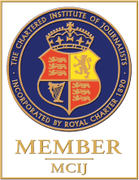

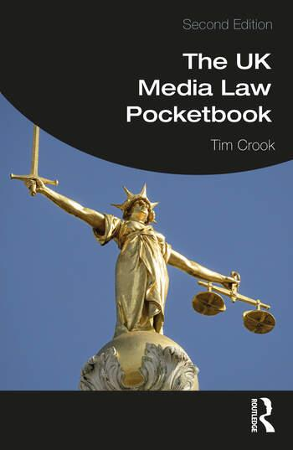
The second edition of The UK Media Law Pocketbook presents updated and extended practical guidance on everyday legal issues for working journalists and media professionals. This book covers traditional print and broadcast as well as digital multimedia, such as blogging and instant messaging, with clear explanations of new legal cases, legislation and regulation, and new chapters on freedom of information and social media law. Links to seven new online chapters allow readers to access all the most up-to-date laws and guidance around data protection, covering inquests, courts-martial, public inquiries, family courts, local government, and the media law of the Channel Islands and the Isle of Man. Tim Crook critically explores emerging global issues and proposals for reform with concise summaries of recent cases illustrating media law in action, as well as tips on pitfalls to avoid.
The UK Media Law Pocketbook is a key reference for journalists and media workers across England, Wales, Scotland, and Northern Ireland. The book’s companion website provides downloadable sound files, video summaries, and updates all the developments in one of the most dynamic and rapidly changing fields of law. Visit https://ukmedialawpocketbook.com.
Preview:- https://www.routledge.com/The-UK-Media-Law- Pocketbook/Crook/p/book/9781138309166?gclid=Cj0KCQjw_r6hBhDdARIsAMIDhV87Y5f5ZJ uc0aPf-FnNl6_hR3uUZgH6lxKek5sxMs9Mk2lAofCHjBYaAs4FEALw_wcB

